“We aspire to be the nation's top real estate company while continuing to be the most trusted name in the industry. We shall deliver superior value to all stakeholders through extraordinary and imaginative spaces created out of deep customer focus and insight.”
Vision: Godrej Properties
Introduction:
In today’s board meeting, Vidush Arya who is General Manager (Marketing), North region in Godrej Properties along with other teammates was appreciated for their performance in the year (2020-2021) and the board also celebrated the success of topping the chart of top 10 real estate company PAN India. Mr. Gaurav Pandey, the regional head of the North zone gave a challenging task to Vidush Arya and his team; to define the future sales expansion strategy for the coming financial year (2022-2023).
Mr. Vidush Arya’s team had to explore all the possible options available within the north region for future upcoming launches and present a report to Mr. Gaurav Pandey on the same. Below are the 5 expansion plans in hand available with Mr. Vidush Arya & team for the coming years, now the big question hovering in his mind and team that which option will be best to take ahead.??
Challenges like Covid-19 which has impacted the complete world and also have a very deleterious impact on the Indian real estate market, where there is a slowdown in the market. Migration of the aspiring youth from a metropolitan city to their home towns due to loss of jobs or change in work style i.e. work from home has led to a decline in the overall growth and sales of Indian residential real estate. In such a challenging time Mr. Gaurav Pandey is aspiring to the growth of 20% increase in sales booking units. Mr. Vidush Arya has been asked to work on this aspirational plan and design the future expansion plan for the north region.
Mr. Vidush Arya sat down with his team and discussed the plan and after the discussion with his team members, he was in a fix on whether doing aggressive marketing and offering hefty discounts and attractive payment plans will give result? Should they sell out the pending inventory available with them in current projects and turn liability-free from the property in hand for all the projects which are ready to move in or in the under-construction stage. As this will also help to increase the cash inflow in the current projects as the profit has already been churned during the project launch. The north team has shown an upward trajectory in sales of inventory available in the NCR region. (Refer to Exhibit 10) The current 600 available residential units for the existing launched project need to be sold out.
The second strategic plan in hand, Vidush Arya’s team who is influenced by the tremendous success and 100% sales within 3 months in their recently launched (2020) project Godrej Retreat which was strategically located on sector 83 in Faridabad, Haryana where the team came up with residential plots for the first time in Nation capital region (NCR) and also it was the first time that Godrej Properties expanded to Faridabad city of Haryana in NCR region. Taking the same success array in hand, the team was planning to expand its horizon to a new region of NCR, i.e. in Ghaziabad city of Uttar Pradesh.
The 3rd expansion plan is to develop a 5acres project in a joint venture deal in tier-II cities of NCR like Ghaziabad which is well connected with Delhi and also has a good future potential of growth due to Government initiatives to develop the infrastructure like metro connectivity. (Refer Exhibit 11) The team plans for the launch of low-rise apartments as the preference for low-rise apartments is high and the options are few in the existing market of Ghaziabad, further, the impact of covid-19 has also promoted the demand for low density and low rise apartments.
The fourth expansion option available to the team is to develop a barren land area of approx. 100 acres in Lucknow which is the capital of the largest state of India i.e. Uttar Pradesh, and has a distance proximity of 530 Km from the country’s capital Delhi. The city is a tier II city that has huge future potential to grow into an IT hub other than the National capital Region in North India. The government is also taking initiatives to develop the city and has thus is expanding the Lucknow airport to develop into an international airport. The future perspective of Lucknow is defined in Exhibit 12.
North team can work on developing an integrated township with all the international amenities, and variants of property like Plots, Bungalows, and apartments on its land parcel. The NCR team has a good experience in successfully running an integrated township as they are currently running a successful township i.e. Godrej Golf Link, in Greater Noida which also comes within the boundaries of Uttar Pradesh a state of India and is part of the NCR region.
Apart from these aggressive plans team was also thinking of tried and tested methods and not looking for new locations as this will have its own set of challenges, especially during the Covid-19. The fifth plan is to launch the project of 7 acres at Gurgaon, on Sohna Road, where the company already has an under-construction icon premium residential apartment project on 7 acres with the name Godrej Nature Plus. The team could take leverage of its already under construction project for marketing and sales. Further, the area was under a high growth trajectory due to the fast developing Sohna road highway. The future perspective of Shona road, Gurgaon is defined in Exhibit 13.
Post discussion Mr. Vidush Arya is to be ready with the report to evaluate the best option in terms of sales volume and units for NCR and finally submit it to Mr. Gaurav Pandey.
Godrej Group:
The Godrej Group was established in 1897 out of a desire to demonstrate economic self-sufficiency and excellence within India in the pre-independence decades. The Godrej Group comprises of a varied business portfolio that includes real estate development, fast moving consumer goods, advanced engineering, home appliances, furniture, security, and agri-care. While a large number of our businesses are privately held, the combined market cap of our publicly listed entities is in excess of USD 15 billion. Ranked as the 2nd most trusted Indian brand, an annual revenue of USD 5 billion, and an estimated 1.1 billion customers across the world that use one or another Godrej product every day, the Godrej Group is amongst India's most diversified and trusted conglomerates.
Godrej Properties brings the Godrej Group philosophy of innovation, sustainability, and excellence to the real estate industry. Each Godrej Properties development combines a 123–year legacy of excellence and trust with a commitment to cutting-edge design and technology.
Godrej Properties was established in 1989 and is part of Godrej Group, one of the largest conglomerates in India. Today, it is one of the leading real estate developers in the country with presence in more than 12 cities. The company witnessed its highest ever sales in FY20 and added 10 new projects. The booking value stood at Rs. 5,915 crore (US$ 839.13 million) in FY20. Its consolidated total income reached Rs. 2,829 crore (US$ 401.33 million) in FY20. (IBEF, July 2021).
Godrej Properties
Godrej Properties has taken strategic initiatives in past to enter the Indian Real estate Market, in which one of the most effective initiates was to work as low assets liability organisation, where most the real estate players spend hefty amount of funds in purchase of land parcel to develop on the other hand Godrej Properties took the leverage of its Brand equity and went for joint ventures and developed limited labilities private firm for each of its project. Godrej Properties strategically identified the land owners who had clear land title and other required approvals for residential project and had properties in good location but ether has no funds to develop them, who lacked construction expertise to developing a quality residential projects or poor customer reputation for residential project delivery in past. Godrej Properties when for profit sharing or revenue sharing models with such small or local level of land owners and then further took over the complete process of development of that land parcel which included architecture design, construction, marketing and sales.
The second most strategic initiative by Godrej Properties was its regular investment in research of best construction practises which can help organisation in timely delivery of residential properties, maintain and further increase the quality standards, and help in reducing the construction cost by saving on time involved in construction and well defined stream lining the construction process which reduced miscellaneous expenses. Thus company strategically designs the different construction practises other than the conventional mode of construction like Pre cast construction model, aluminium frame work model, fusion model and other future construction practises which were coming in the market. Godrej Properties also invested in sustainable structure thus designed Indian Green Building Council (IGBC) certified residential and commercial properties.
The third strategic initiative by the organisation was to develop a highly competitive Customer Relationship Team to maintain high service standards. Any under construction residential project has a life span of 4 years minimum from the day of launch thus customer require regular inputs on the changes and the development taking place on the project and in nearby surroundings, future payment timing and many other backend support. Since real estate investment was a high investment product customers requires individual attention and support especially about the paper work, Property Loan and government processes. Secondly to maintain the liquidity of funds timely payment collection is a major requirement for the organisation. Thus company invested hefty on the same. The Company was pioneer in designing NPS (Net Profit Score) for its project site to identify the customer loyalty and regular monitored the issues which client faced and worked on them on individual project basis. Company also came up with attractive payment options to secure its customer trust, they developed P@CE also called APS (advance payment scheme) where clients could make an advance payment to their future coming demand and in return earn an attractive rate of return, and this initiate helped the company to generate additional funds, avoid bad debts by customers and further secure its loyal customer.
The organizational chat for Godrej Properties in Exhibit 1 and Exhibit 2.
The company has an extended portfolio in India’s major tier I and developing tier-II cities. The company has focused on 4 major cities: Bangalore, Pune, Mumbai, Ahmedabad Kolkata, and NCR (National capital region) which include Delhi, Gurgaon, Noida, Greater Noida, and Faridabad. The list of projects in different regions of India is shared in Exhibit 9.
Real Estate Industry Scenario:

Today real estate is one of the most globally recognised sectors, which majorly comprises five sub-sectors - Residential space, Retail space, Hospitality space, and Commercial space. (Error! Hyperlink reference not valid. July 2021) In India, the real estate sector is the second-highest employment generator, after the agriculture sector. The Indian real estate sector contributes seven per cent to the gross domestic product (GDP). It is a USD 200-billion industry and set to become a USD 1-trillion sector by 2030 and contribute 13% to the country’s GDP by 2025. Refer Exhibit 13.

Landmark Changes in 5 years
In the past 5 years, Indian Real Estate has seen 4 major landmark changes which completely redefined the fragmented and unorganised Indian real estate destiny which includes RERA introduction, (Real estate regulation and development act enacted on 25th March 2016), Demonetisation (8th Nov 2016), GST rates (Goods and Service Tax launched on 1st July 2017), NBFS crisis (non-banking financial companies crises in Nov 2018) and now the Covid -19 pandemic (Pandemic caused a nation-wide lockdown on 24th March 2020) (2021 India Real Estate Outlook, JLL)

Impact of Covid-19 on Residential Real Estate
The construction and finance, and real estate and professional services sectors have shown a negative growth of 8.6 percent and 1.5 percent respectively between April 2020 and March 2021 due to the impact of COVID-19, (National Statistical Office, on 31st May 2021). In this tough time the rise in demand of the residential segment which contributes to 80% of the Indian real estate sector, was a ray of hope, in 2020, the residential market showed quick signs of recovery and the growth momentum continued in Q1 2021. The sales volume recovered to more than 90% of the volumes witnessed in Q1 2020 (pre-COVID) across the top 7 cities (Tier 1 cities of India, including Bengaluru, Chennai, Delhi NCR, Hyderabad, Kolkata, Mumbai, and Pune). This has been on the back of low home loan interest rates, stagnant residential prices, lucrative payment plans & freebies from developers and government incentives such as the reduction of the stamp duty in some states. The ease of lockdown restrictions and the commencement of the vaccination drive have further aided in bringing buyers back to the market. (Indian office and residential market update: Q1 2021 by JLL)

Planning for 2022

Gagan Pandey confided in Vidush Arya that Godrej’s senior management had decided to tie a greater proportion of 2022 employee compensation to regional performance; their plan was to reward regions that met or exceeded sales objectives and to recognize those that underperformed. Arya understood the pressure Gagan was under. Gagan Had given two days to produce a revised plan that come closer to his goal of a 20 percent increase in sales. Arya started thinking about how to meet the given target?
Arya reviewed his initial projections for property sales in India. He was trying different product mix changes. He opened his laptop to build a projected sales statement for 2022 & plans to achieve the given target.

***************************************************************************

Exhibit 1: Organisation Structure
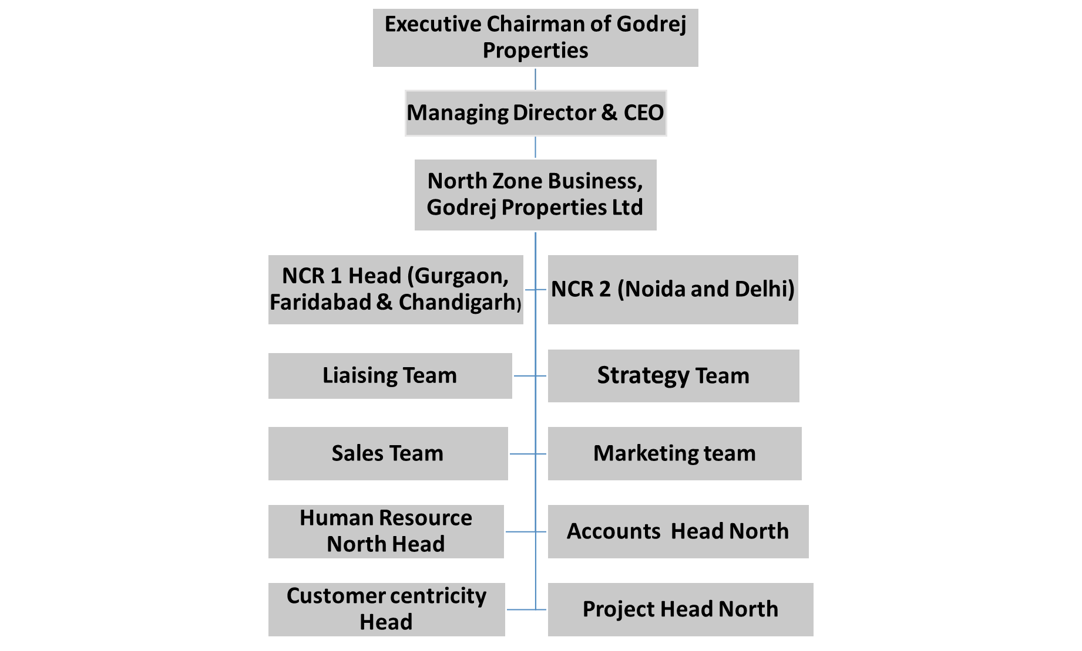
Exhibit 2: Region wise Organisation Structure
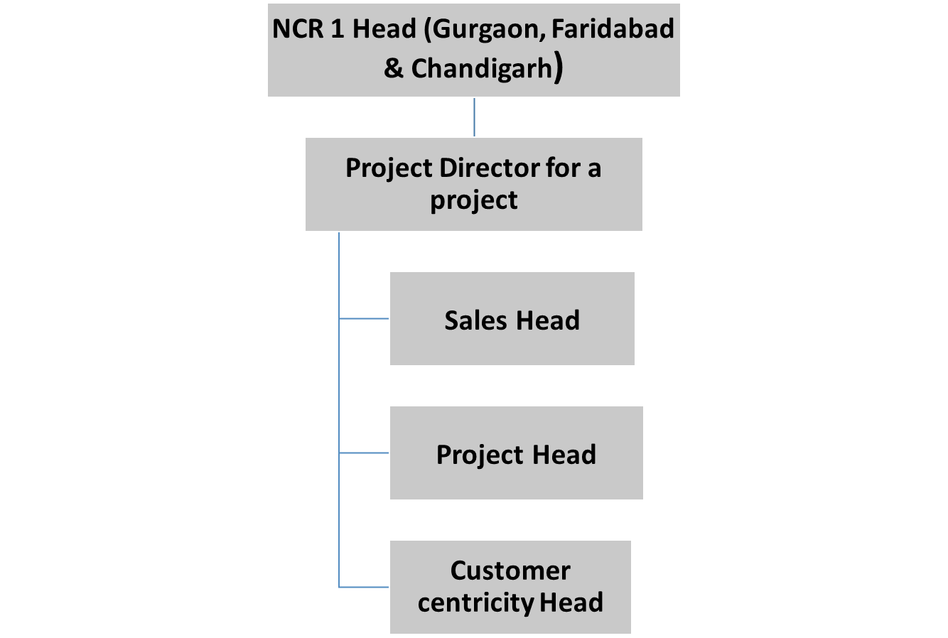
Exhibit 3: Type of Residential properties
Type | Details
Bungalows | They are independent houses that can either be stand-alone (private built and owned) or a group of independent houses build by developers, forming a society. The bungalows are either single or multi floored (generally up to 2 floors).
Row Houses | Row houses are series of houses which has similar plans and located side by side to adjacent houses and shares a common wall. They are different from villas as they are joined by common walls. The design pattern, architecture, and appearance are similar.
Low rise residential building/Builder Floor | These are residential units that consist of around four to five floors with a common area and other amenities for the residents. It has multiple residential units in each floor with all the facilities required for living.
High rise residential building | These are residential units that have similar facilities and planning like that of low-rise buildings, however consist of six or more floors.
Townships | They have facilities and infrastructure like a town where all civic amenities such as roads, water, electricity, school, healthcare units, garbage disposals, parks, recreational centre, etc. are provided within a gated community. These are residential complexes constructed either by the government or by private realtors and usually situated within suburbs.
(Research Gate, 2018)

Exhibit 4: Real Estate affordability matrix
TOP 7 CITIES: Tier 1 cities
City | 2010 | 2015 | 2020
Mumbai | 93% | 94% | 61%
NCR | 53% | 51% | 38%
Bengaluru | 48% | 48% | 28%
Pune | 39% | 38% | 26%
Chennai | 51% | 43% | 26%
Hyderabad | 47% | 39% | 31%
Kolkata | 45% | 44% | 30%
Ahmedabad | 46% | 36% | 24%
(Knight Frank Research- Residential and Office - July – December, 2020)

Exhibit 5: Growth in residential market in Tier I Cities of India
TOP 7 CITIES: Residential Market Viewpoints PAN India Q1 2021
City | New Launches | Sold Units | Available Inventory | Avg. Price (INR/sf.)
NCR | 6,750 | 8,790 | 1,68,360 | 4,650
MMR | 14,820 | 20,350 | 1,97,040 | 10,750
Bengaluru | 7,690 | 8,670 | 58,350 | 5,060
Pune | 13,820 | 10,550 | 96,440 | 5,580
Hyderabad | 12,620 | 4,400 | 44,980 | 4,240
Chennai | 4,620 | 2,850 | 36,220 | 4,990
Kolkata | 1,810 | 2,680 | 40,470 | 4,400
PAN India refers to Top 7 cities of India only Average price in INR/sf as quoted on BSP on BUA
(Anarock Research: Residential Market Viewpoints, PAN India-Q1, 2021)

Exhibit 6: Based on price the Indian Residential Real estate Segmentation
Type | Cost of Property
Affordable | <INR 40 Lakh
Mid-end | INR 40 Lakh - INR 80 Lakh
High-end | INR 80 Lakh - INR 1.5 Cr
Luxury | INR 1.5 Cr - INR 2.5 Cr
Ultra-luxury | > INR 2.5 Cr

Exhibit 7: Type of Indian Residential Real Estate Property available for Purchase
Launched Projects | Property recently launched by builder, construction still not begin at site
Under Construction Projects | Property were construction has begun but Occupation Certificate not received for the property.
Ready to Move in | Occupation certificate received for the property and the property is habitable.

Exhibit 8: 15 Types of residential matrix available:
Gurgaon:
Type | Cost of Property | Launched Projects | Under Construction Projects | Ready to Move in
Affordable | <INR 40 Lakh
Mid-end | INR 40 Lakh - INR 80 Lakh
High-end | INR 80 Lakh - INR 1.5 Cr
Luxury | INR 1.5 Cr - INR 2.5 Cr
Ultra-luxury | > INR 2.5 Cr

Exhibit 9: Project Brief of Godrej Properties:
Banglore, Ahmedabad and Kolkata

Exhibit 10: Sales graph of 3 years of Nation Capital Region of Godrej Properties:
S.No | Project Name | Total No of Units | Product Type | Units Sold 2017-18 | Units Sold 2018-19 | Units Sold 2019-20 | Total Unit Sold
1 | GODREJ 101 | 342 | High rise Apartments
2 | Godrej Aria |  | High rise Apartments
3 | GODREJ AIR | 511 | High rise Apartments
4 | GODREJ MERIDIEN | 754 | High rise Apartments
5 | GODREJ HABITAT | 384 | High rise Apartments
6 | GODREJ NATURE PLUS | 1068 | High rise Apartments
7 | Godrej Oasis |  | High rise Apartments
8 | Godrej Icon |  | High rise Apartments
9 | Godrej Woods | 432 | High rise Apartments
10 | Godrej South Estate | 372 | High rise Apartments
11 | Godrej Palm Retreat | 856 | High rise Apartments
12 | Godrej Nest & Nurture | 1090 | High rise Apartments
13 | Godrej Retreat |  | Plots
14 | Godrej Golf Links | 2750 | Villas, High rise Apartments, Low rise Apartments
a | EXQUISITE | 308 | 125 sq. yrd. I 2835 sq. ft. Villas  150 sq. yrd. I 3450 sq. ft.
b | EVOKE | 95 | 180 sq. yrd. I 3840 sq. ft. Villas
c | SUITES | 660 | High rise Apartments
d | PARK LANE / WINDSOR | 114 | Low rise apartments
e | CREST | 308 | 125 sq. yrd. I 2835 sq. ft. I Villas

References:
Anarock Research: Residential Market Viewpoints, PAN India-Q1, 2021
Residential Market Viewpoints PAN India Q1 2021
IBEF Report, July 2021
Research Gate, 2018
Knight Frank Research- Residential and Office - July – December 2020
Pandemic caused a nationwide lockdown on 24th March 2020) (2021 India Real Estate Outlook, JLL
Error! Hyperlink reference not valid. July 2021
https://housing.com/news/buyers-guide-selecting-property-ghaziabad/
https://timesproperty.com/news/post/lucknow-a-haven-of-affordable-realty-blid755

